Establish an MDF with rack to accommodate network equipment, e.g. switches, router, patch panels, etc.

Dedicated Category 6 Riser cable to be routed to each designated field jack and AP. Labeling will be accordance to TIA standards.

Wire to be routed above drop ceiling where applicable, J hooks will be used at least every ten feet.

Wall penetrations will be sleeved and fire caulked to meet code.

Category 6 Keystone Printer Connection

Category 6 Keystone VoIP Connection

Category 6 Keystone Computer Connection

Access Point

Elementary Subnet

10.160.30.0/28

Gi0/0 10.160.30.254/28

Se0/1 10.160.60.253/28 Link to high school 1941 Router Se0/1 10.160.60.254/28

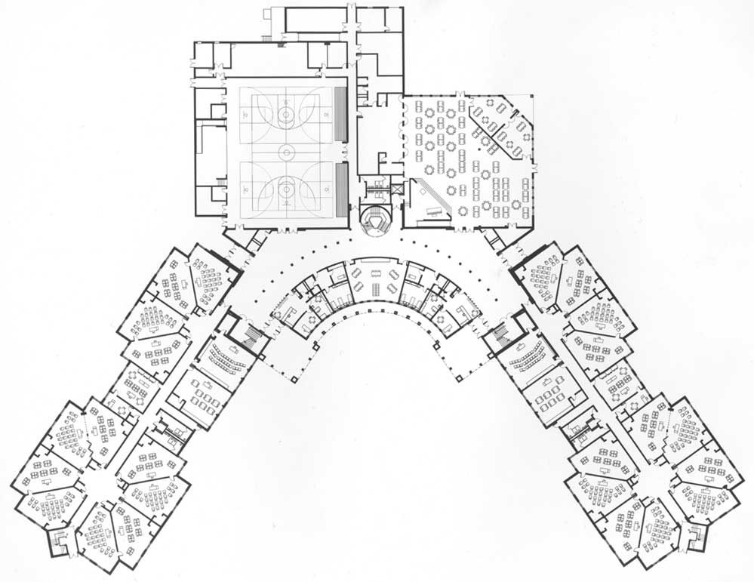

Establish an MDF with rack to accommodate network equipment, e.g. switches, router, patch panels, etc.

Dedicated Category 6 Riser cable to be routed to each designated field jack and AP. Labeling will be accordance to TIA standards.

Wire to be routed above drop ceiling where applicable, J hooks will be used at least every ten feet.

Wall penetrations will be sleeved and fire caulked to meet code.

Middle School Subnet

10.160.40.0/28

Gi0/1 10.160.40.254/28 Link to switch to support LAN connections

Se0/1 10.160.70.253/28 Link to high school 1941 Router Se0/2 10.160.70.254/28

High School Subnet

10.160.50.0/28

Gi0/1 – 10.160.50.254/28 Link to switch to support high school LAN connections

Se0/1 – 10.160.60.254/28 Link from high school 1941 router Se0/1 10.160.60.253/28

Se0/2 – 10.160.70.254/28 Link from middle school 1941 router Se0/1 10.160.70.253/28